1. Maximum XOR of Two Non-Overlapping Subtrees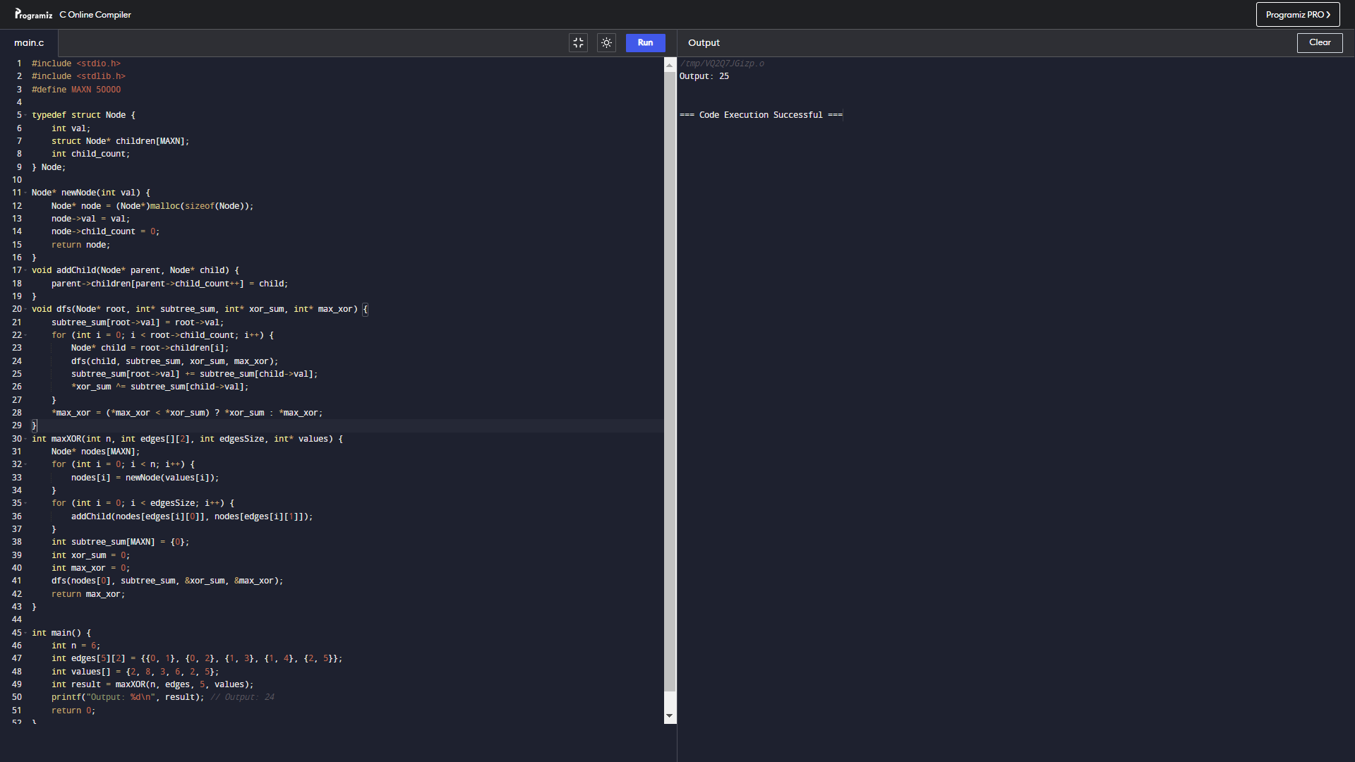
2. Minimum Cuts to Divide a Circle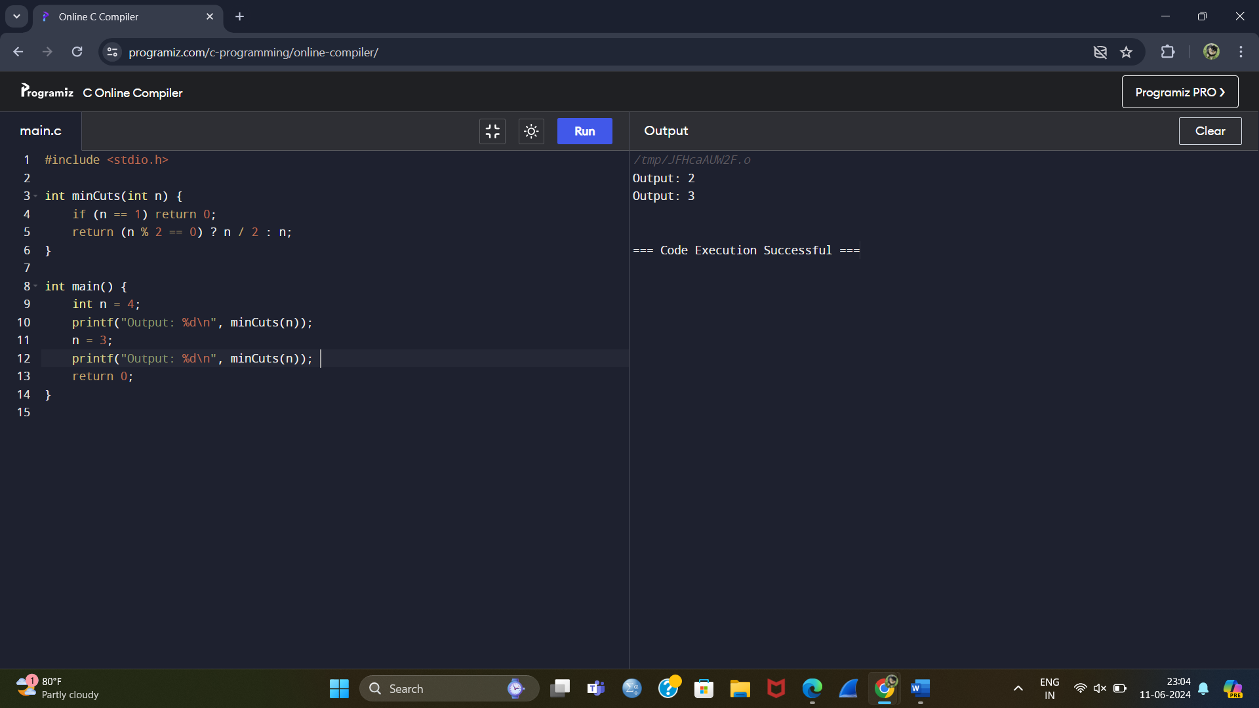

3. Form a Chemical Bond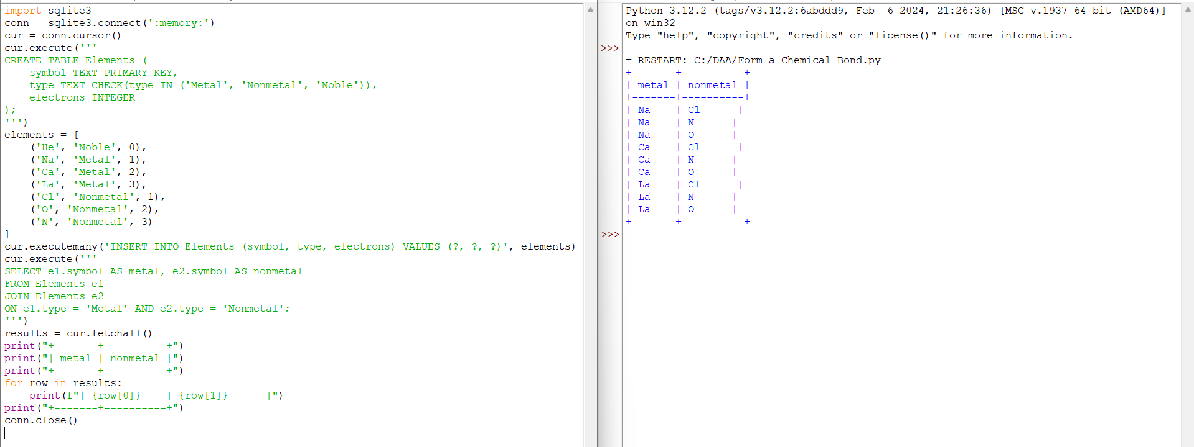

4.&5. Minimum Penalty for a Shop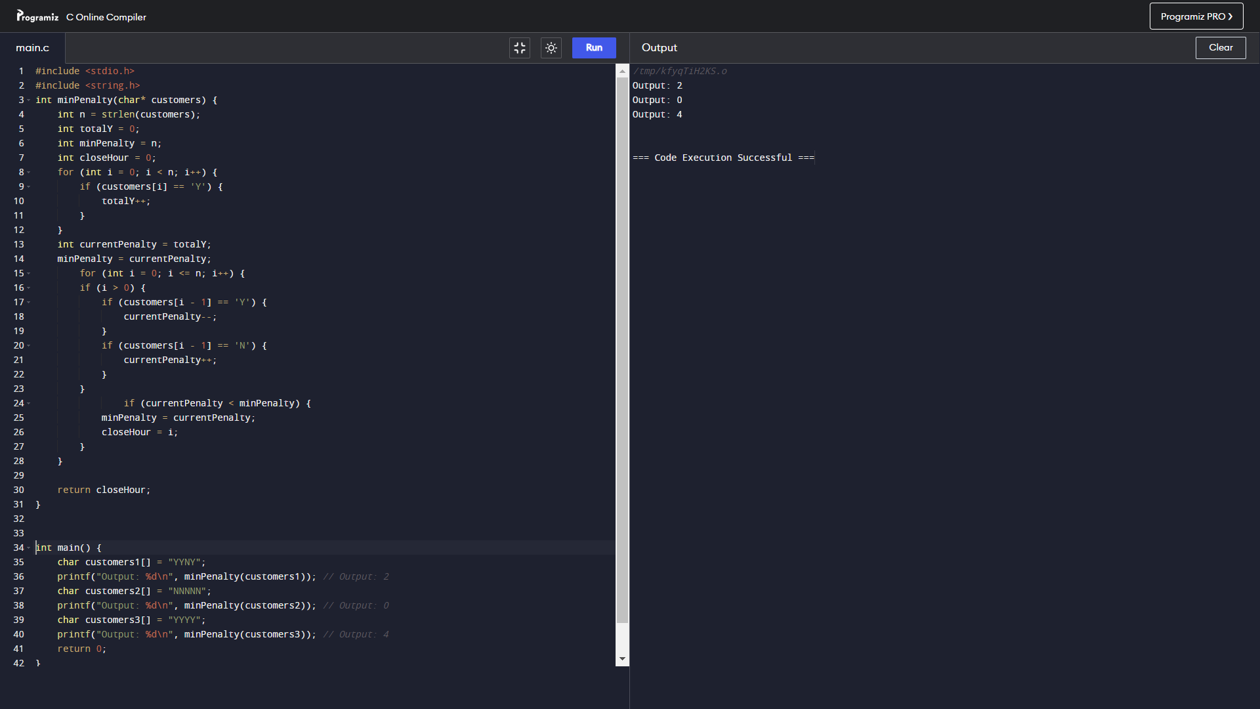

6. Count Palindromic Subsequences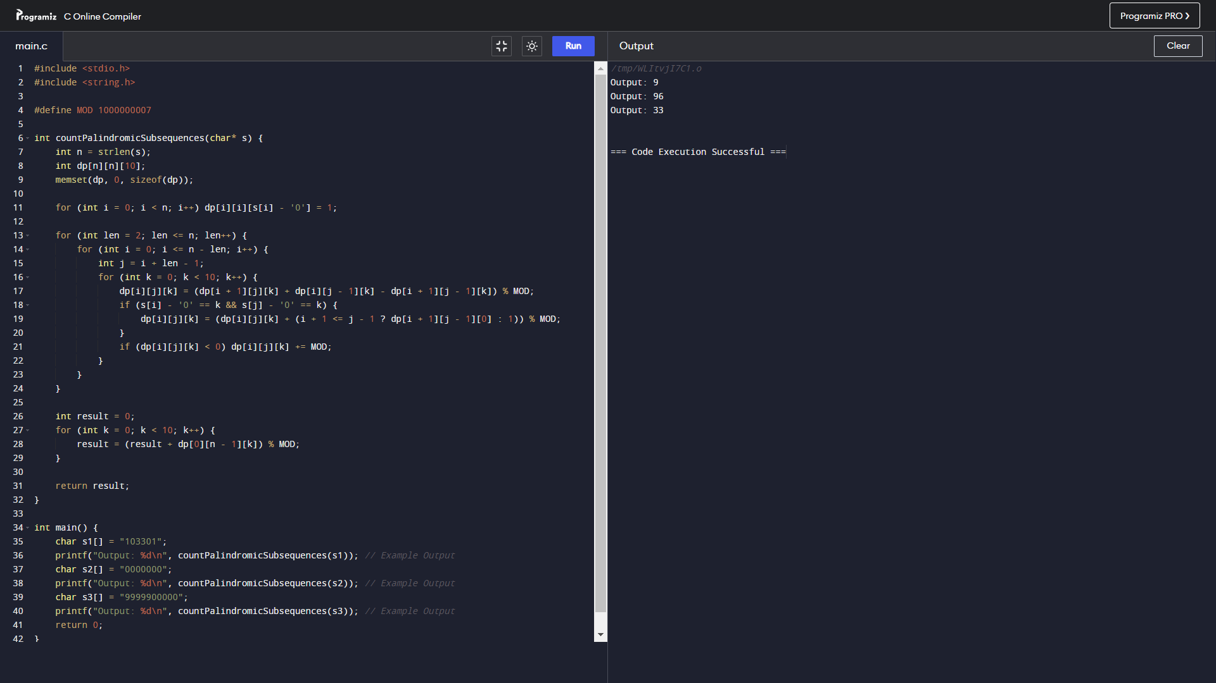

7. Find the Pivot Integer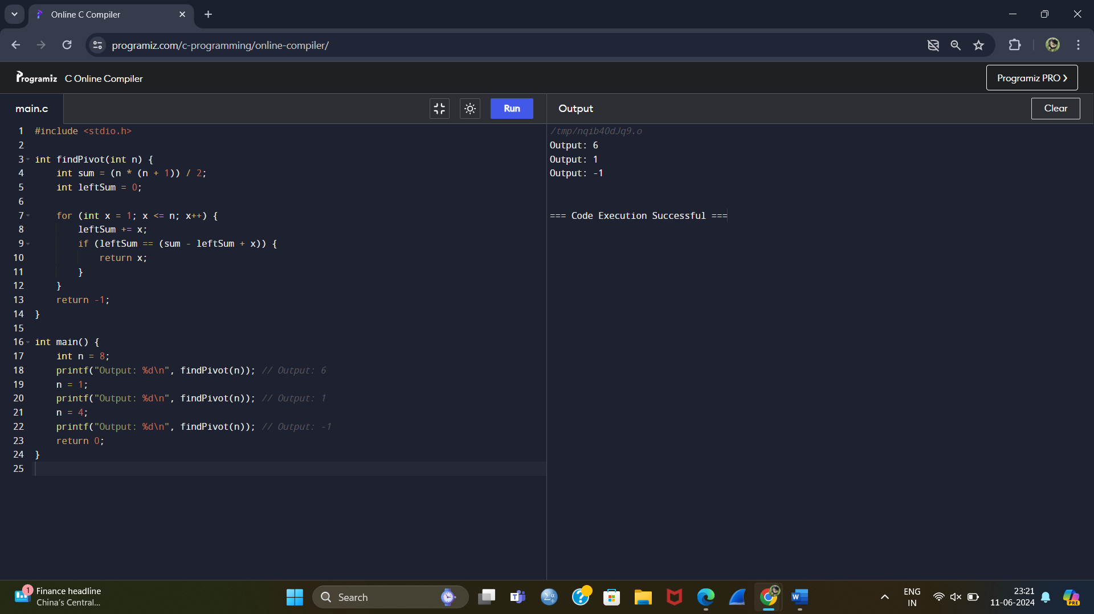

8. Append Characters to String to Make Subsequence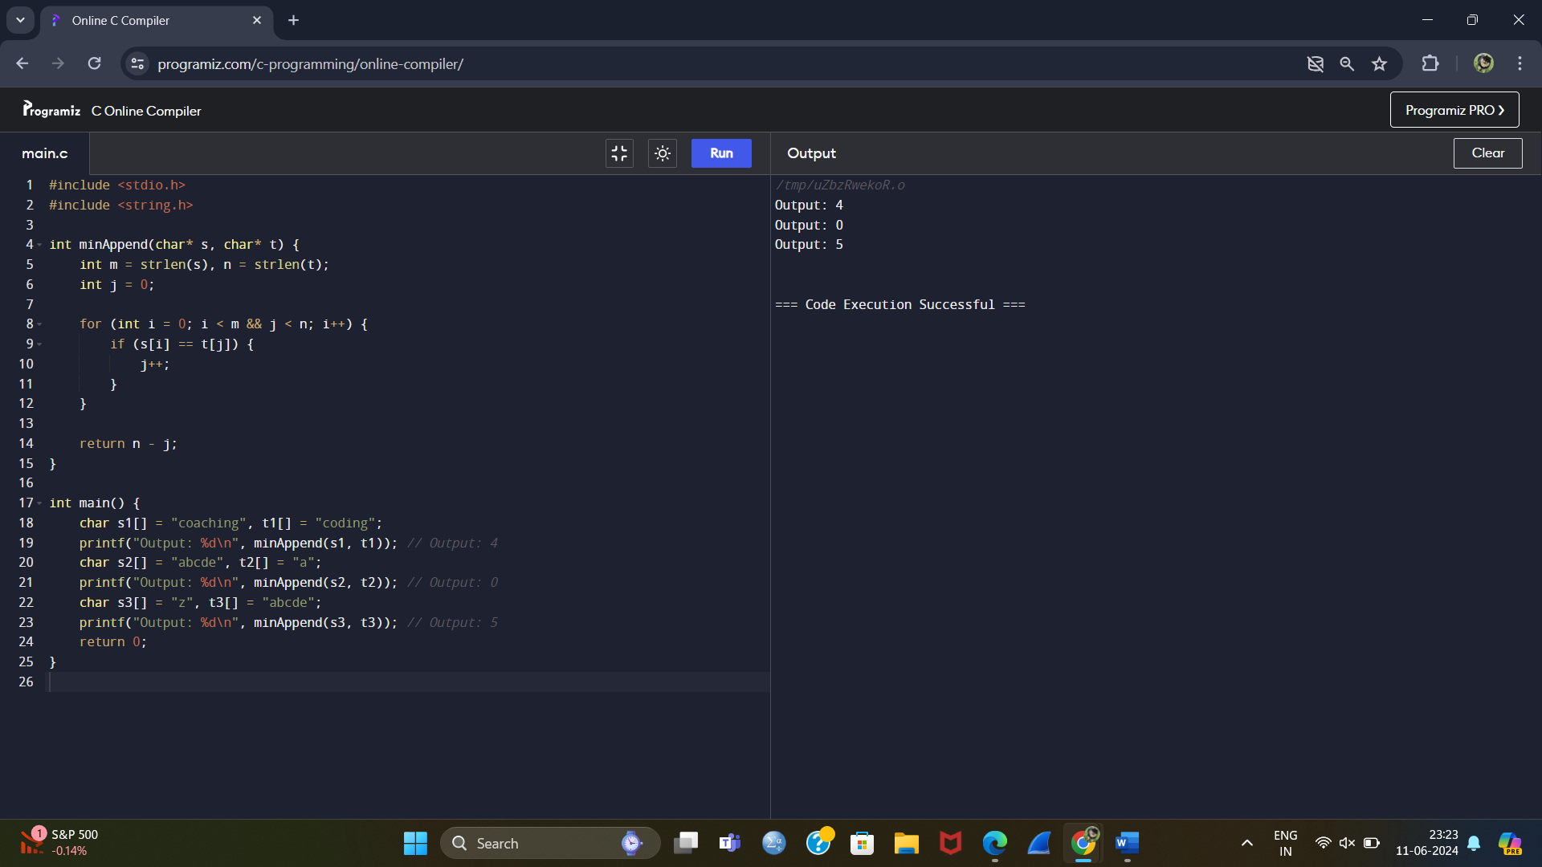

9. Remove Nodes From Linked List10. Nodes Not Connected to Graph